Stepper Motors Control With

STM32F4xx

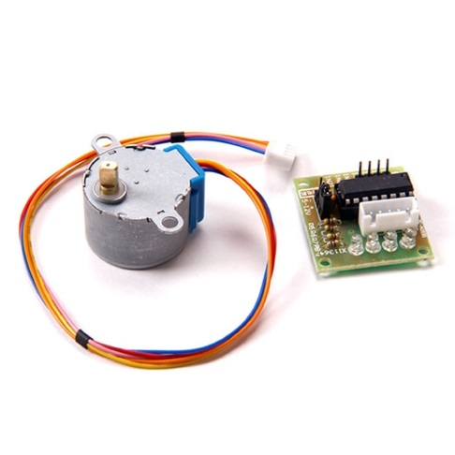

A stepper motor divides full rotation into number of equal steps. It finds great application in the fields of Robotics. Today I will explain you how to interface stepper motor with STM32.

Stepper motors generally comes along with an IC **ULN2003**. This IC is used to drive motor because microcontroller pins are unable to provide sufficient current to drive these motors. There are three different types of stepping modes used for stepper motors

* Wave Drive
* Full Drive
* Half Drive

**Wave Drive**

In this mode only one stator electromagnet is energized at a time. It has the same number of steps as the full step drive.

[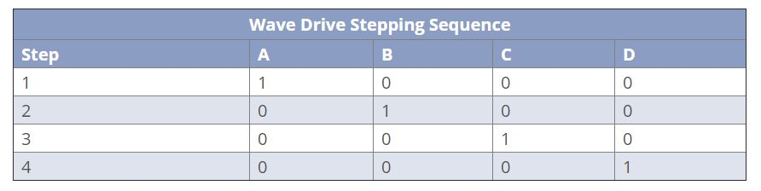](http://controllerstech.com/wp-content/uploads/2018/06/3.jpg)

##### ****Full Drive****

In this mode two stator electromagnets are energized at a time and the motor runs at full torque.

[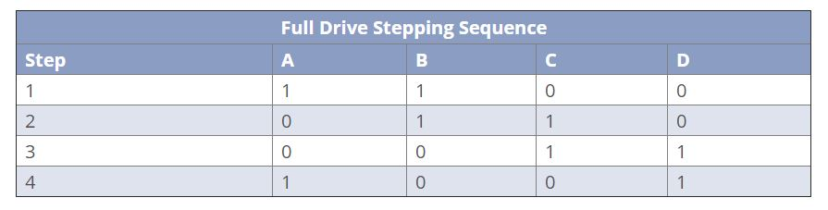](http://controllerstech.com/wp-content/uploads/2018/06/4.jpg)

##### ****Half drive****

In this stepping mode, one and two phases are energized alternatively. This mode is used to increase the angular resolution of the motor but the torque is reduced.

[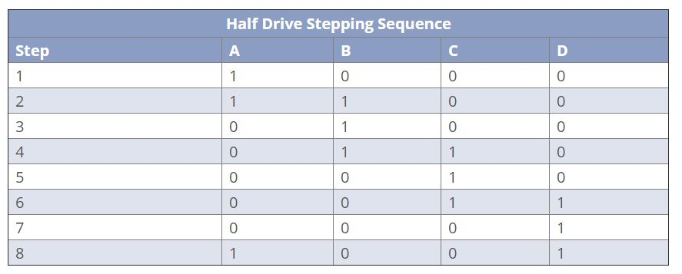](http://controllerstech.com/wp-content/uploads/2018/06/5.jpg)

**CONNECTIONS**

PC0 IN1

PC1 IN2

PC2 IN3

PC3 IN4

**How to program?**

Wave drive is the simplest way to drive the motor and to explain the working of the stepper motor. So I am going to use wave drive to explain how this motor works and how to program it.

According to the figure above (wave drive), we can see that in order to rotate motor we need to turn one pin HIGH at a time. This is called a step. And the combination of those 4 steps is called a sequence. For the motor to complete a full 360 degree rotation, 2048 steps are required in wave drive and Full drive. That means we need to give 2048/4 = 512 sequences.

However in Half drive, the motor require 4096 steps. But the sequence have 8 steps now (shown in the fig above) so we need to give 4096/8 = 512 sequences.

This was for one complete rotation.

Now let’s say we want to rotate the motor by a particular angle for example 10°. So,

For 360° 🡪 512 Sequences

10 🡪 X Sequences

X = (10 * 512)/360 = 14 Sequence. To achieve that we need just to change sequence in the for Loop in main.c

Also if you want to vary the RPM, you need to change the time delay between steps.

Code is available on my GitHub☺ .

NB: You should supply the ULN2003 with a separate power supply voltage 5V and 12V, because it should have enough current to turn on.

Current provided by Stm32 Development Board may be not enough to turn on DC Motor